**Project 3 Part 3 (full recursive approach O(nlog^2n))**

Name: __________Michael Fatemi_________ Period: ______7______

Date: __________11/18/2020______(REVISED 12/16/2020)________

Is your lab name l033?(lowercase L followed by digits 033) _____Yes______

Did you created a class to store a point? _____Yes______

Did you use a vector to store the points you generated? _____Yes______

Did you use at least one iterator to traverse the vector you created? _____Yes______

Did you sort using the sort method offered by C++? _____Yes______

Did you use at least one iterator to traverse the vector you created? _____Yes______

Does your main contain only 2 calls of: part2() and part3() (NO part1!!)? _____Yes______

(in main you may also have the part to display results for the 2 methods and them also in the txt file)

1. **Paste here a clear picture of the graph that compares the running times of the “initial recursive” algorithm and “full recursive” algorithm versus number of points. (use 2 different colors for the 2 graphs, colors that can be visible even if you print in black and white). Each point on this graph should be an average of several runs for that size:**

Each of these results is the average of 10 runs.

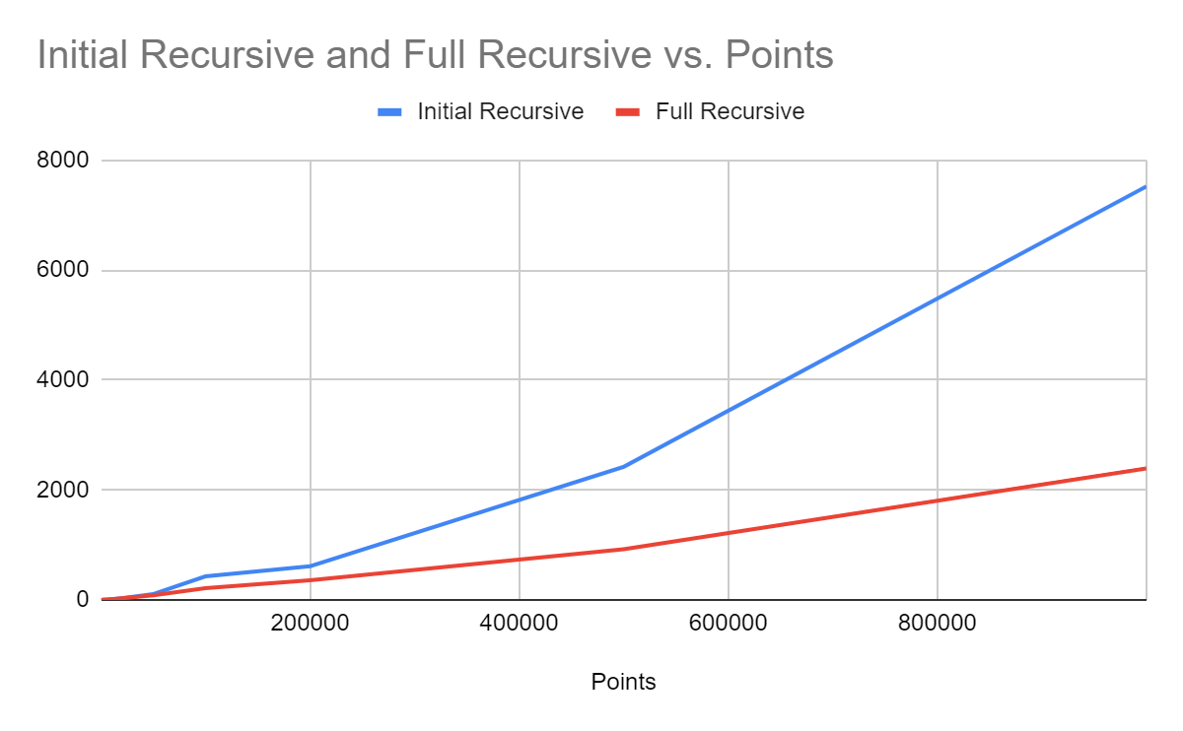

1. **Paste here the content of the results.txt when you run your lab on the content of the file points10k.txt and points100k.dat**

**For 10k:**

Recursive Original x [10] 139ms (13/cycle) 10000 points

(0.49999999999999989,0.50000000000000111) (0.49999999999999994,0.50000000000000111) 5.5511151231257827e-017

Recursive Optimized x [10] 132ms (13/cycle) 10000 points

(0.49999999999999883,0.50000000000000033) (0.49999999999999889,0.50000000000000033) 5.5511151231257827e-017

**For 100k:**

Recursive Original x [10] 4354ms (435/cycle) 100000 points

(0.49999999999973127,0.49999999999889994) (0.49999999999975941,0.49999999999890893) 2.9545963426100509e-014

Recursive Optimized x [10] 1918ms (191/cycle) 100000 points

(0.49999999999973127,0.49999999999889994) (0.49999999999975941,0.49999999999890893) 2.9545963426100509e-014